Study on the Effect of Type of Environment on Recalling Capacity of a Student

2024-11-24

## Acknowledgment

This work was carried out under the guidance of **Prof.Achint Nigam**, who provided invaluable advice and support throughout the project.

# Authors Information

| Name | BITS ID |
| --- | --- |
| Parag Chittora | 2024H1540802P |
| Sarvesh Kulkarni | 2024H1540820P |
| Abhinav Pratap Singh | 2024H1540818P |
| Yash Dwivedi | 2024H1540853P |
| Adinath Ghosh | 2024H1540814P |

# Introduction

In an era where educational environments are increasingly being scrutinized for their impact on student performance, understanding how different environmental factors affect cognitive functions has become essential. This report outlines a study aimed at exploring how variations in lighting and noise levels influence students’ recalling capacity and hesitation during recall. The study seeks to provide insights into designing optimal learning environments to enhance memory recall and reduce cognitive hesitation.

# Problem Statement

The study aims to investigate how different environmental conditions, specifically lighting conditions (dim versus bright) and noise levels (quiet versus loud), influence:

1. Recalling Capacity: Measured on a scale of 1 to 10 based on the ability to recall random images.  
2. Number of Pauses: A count of hesitation during the recall task.

Additionally, the study incorporates gender differences to examine potential variability in responses across these environments.

# Motivation

Recent studies have highlighted that environmental factors like lighting and noise significantly affect cognitive performance, such as memory recall and hesitation. However, the combined influence of these factors in controlled academic settings remains underexplored. By examining recalling capacity and number of pauses, this research addresses a critical gap, offering valuable insights for educators and facility planners to design conducive learning environments that enhance both performance and confidence.

# Research Design

### Action Plan

#### Objective: To assess the impact of room lighting (dim versus bright), noise levels (quiet versus loud), and gender (male versus female) on:

1. Recalling Capacity: A measure of memory recall.  
2. Number of Pauses: A measure of hesitation during recall.

### Variables:

• Independent Variables:  
Lighting of Room: Dim versus Bright  
Noise Level of Locality: Quiet versus Loud  
Gender of Student: Male versus Female  
• Dependent Variables:  
Recalling Capacity: Measured on a scale from 1 to 10.  
Number of Pauses: Total count of hesitations during recall.  
• Control Variable:  
 Time of the Day: Ensures consistency in environmental conditions.

### Sample

Approximately 300 students participated in the study. They were divided into 8 groups based on the combinations of lighting, noise, and gender, ensuring equal representation.

# Methodology

## Phase 1: Preparation

Set up 8 distinct environments based on combinations of lighting, noise levels, and gender:

1. Dim lighting with Quiet noise (Male)  
2. Dim lighting with Quiet noise (Female)  
3. Dim lighting with Loud noise (Male)  
4. Dim lighting with Loud noise (Female)  
5. Bright lighting with Quiet noise (Male)  
6. Bright lighting with Quiet noise (Female)  
7. Bright lighting with Loud noise (Male)  
8. Bright lighting with Loud noise (Female)

Each environment was designed to simulate realistic study conditions while maintaining consistency across groups.

## Phase 2: Exposure

• Each student was exposed to a PowerPoint presentation containing random images.  
• The images were selected to ensure variety and randomness, reducing the influence of familiarity on recall.

### Displaying the presentation used:

knitr::include_graphics("slide1.png")

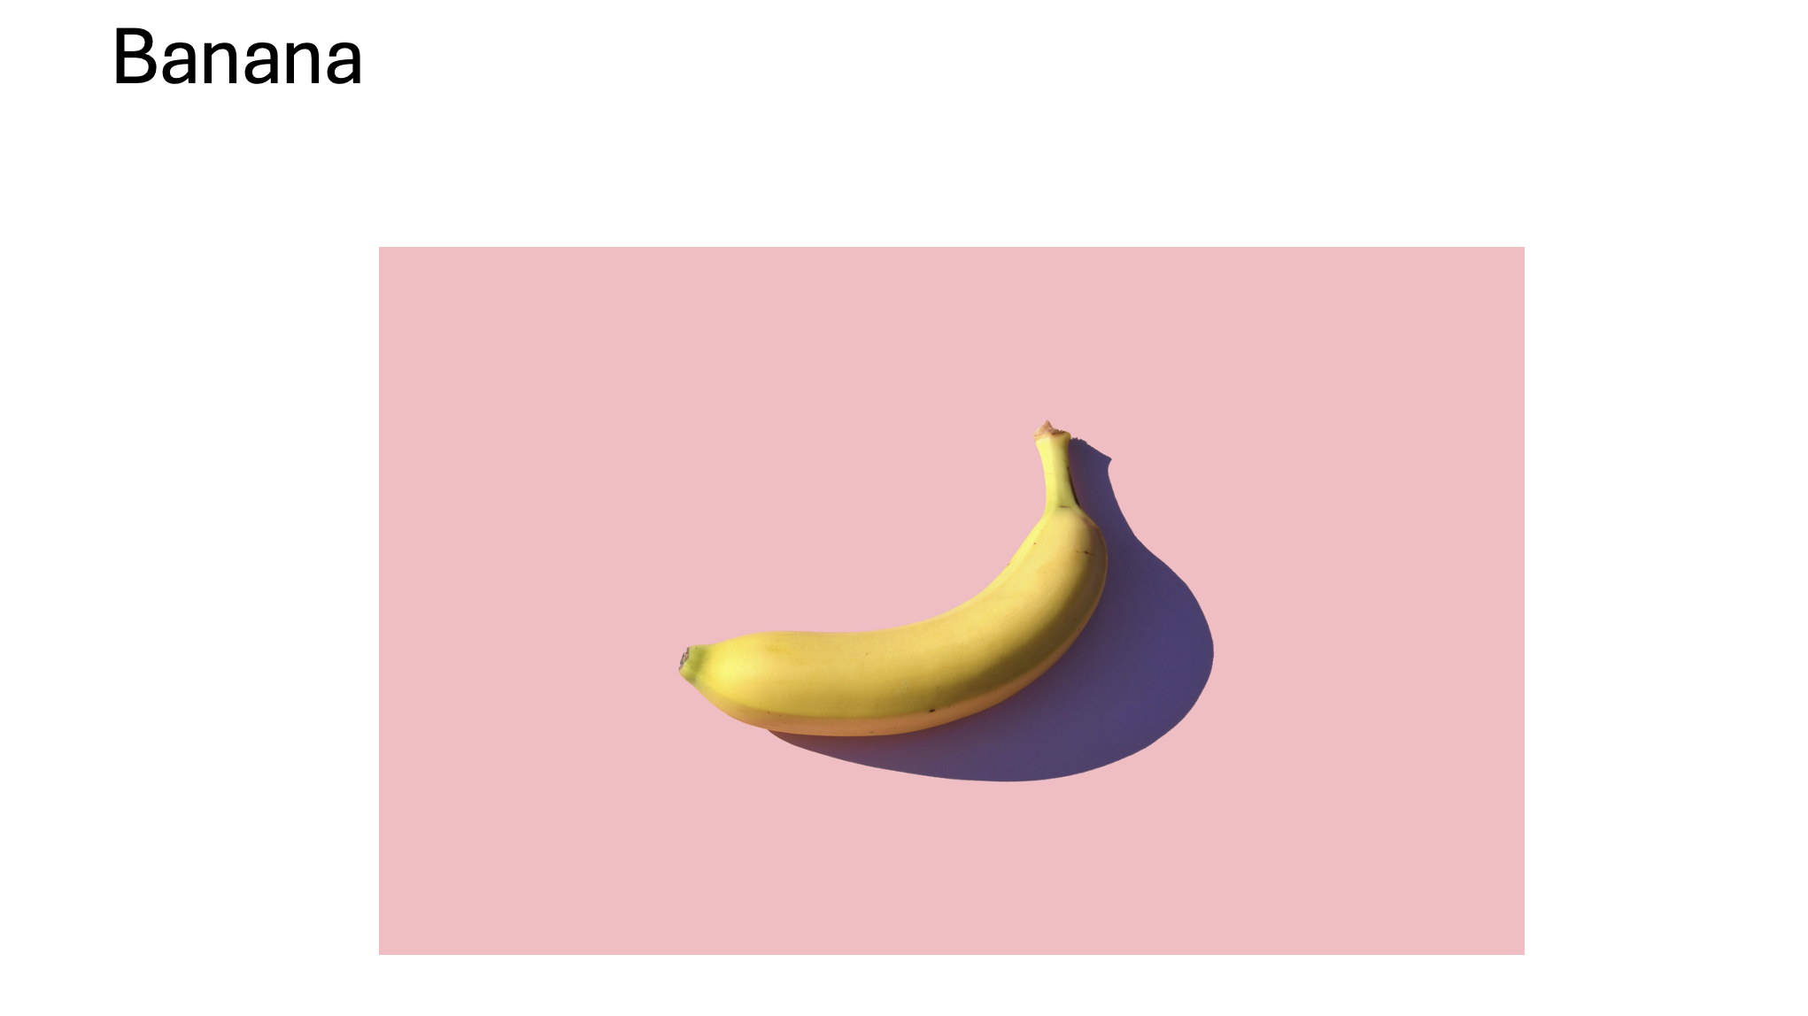

knitr::include_graphics("slide2.png")

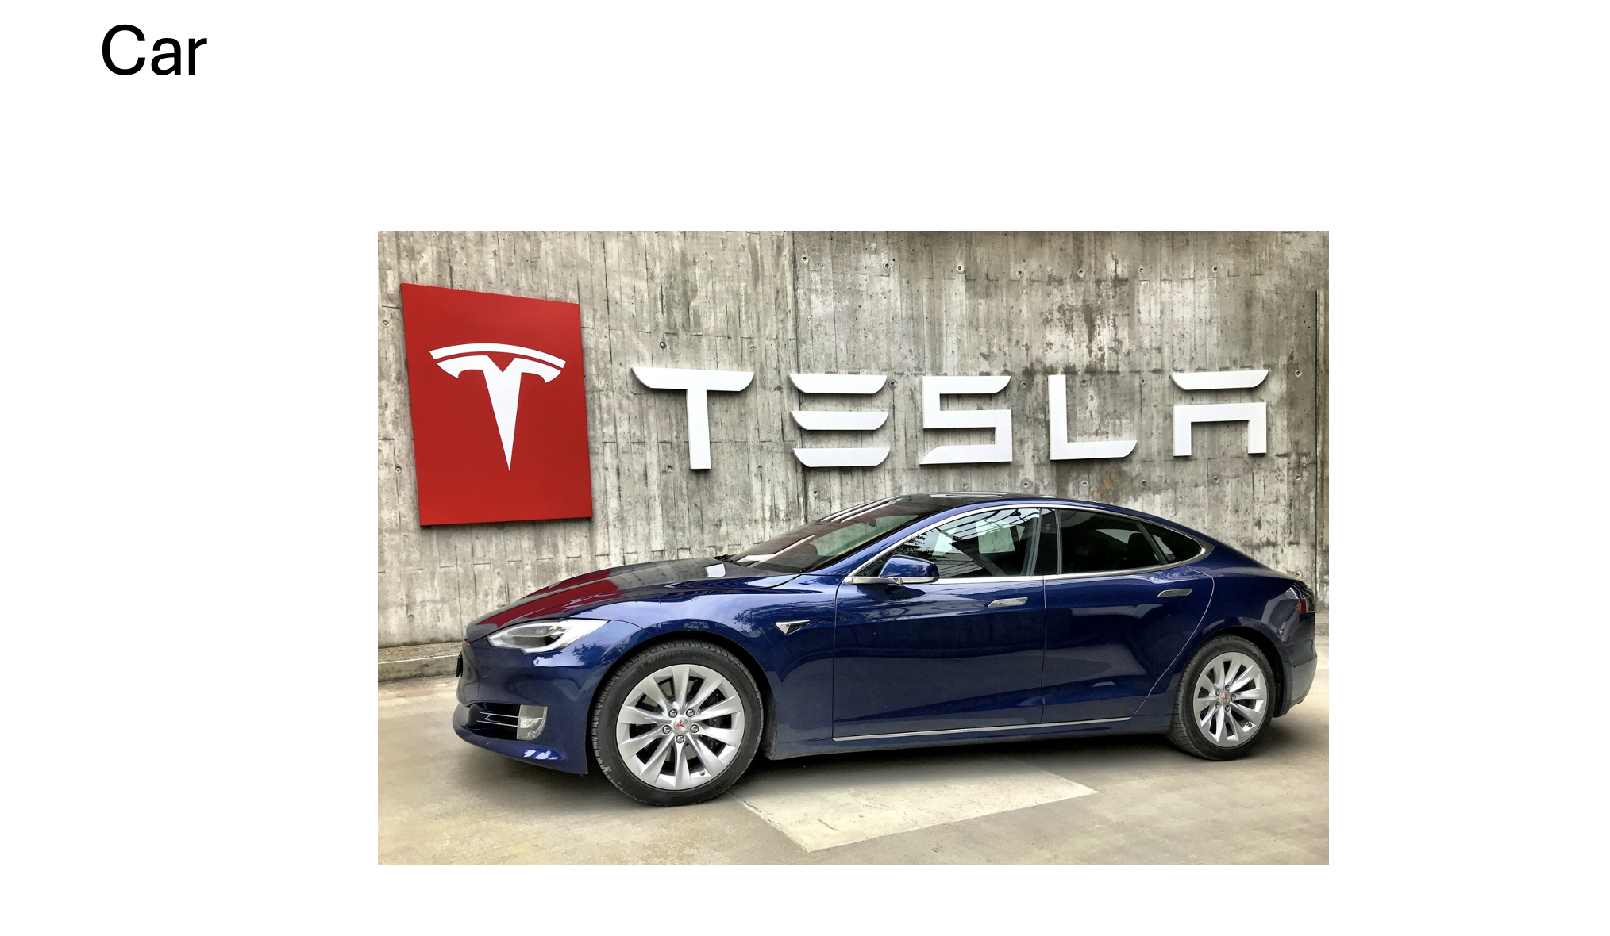

knitr::include_graphics("slide3.png")

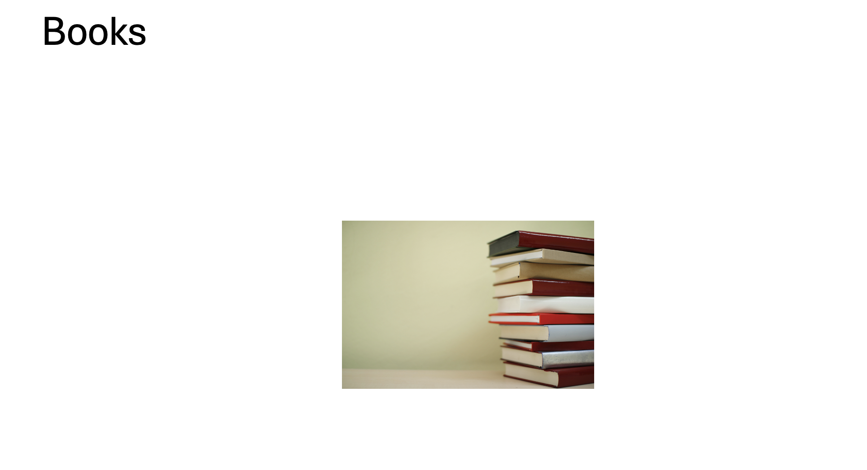

knitr::include_graphics("slide4.png")

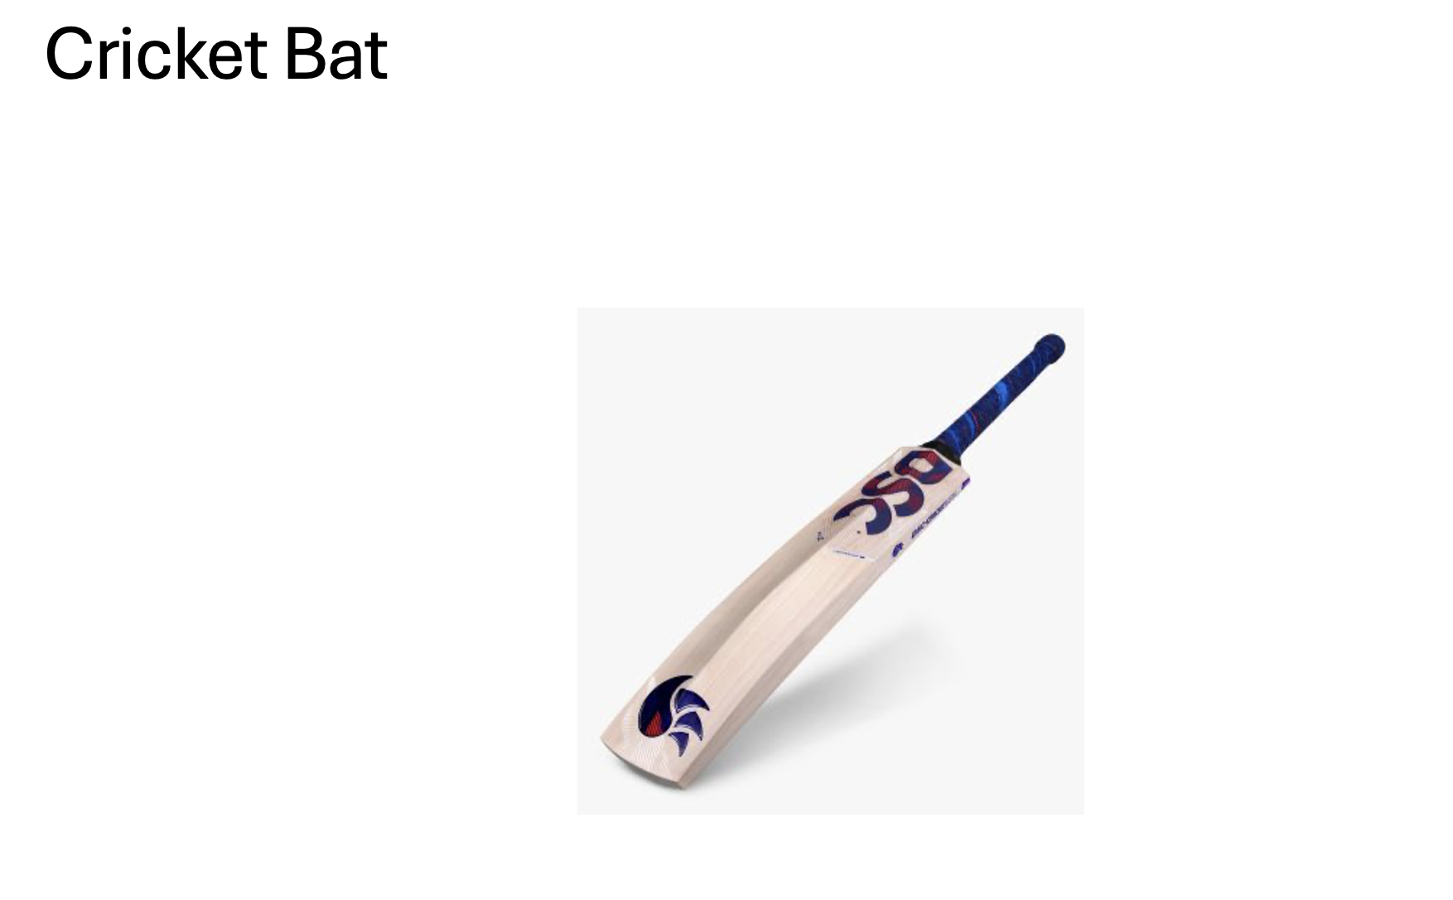

knitr::include_graphics("slide5.png")

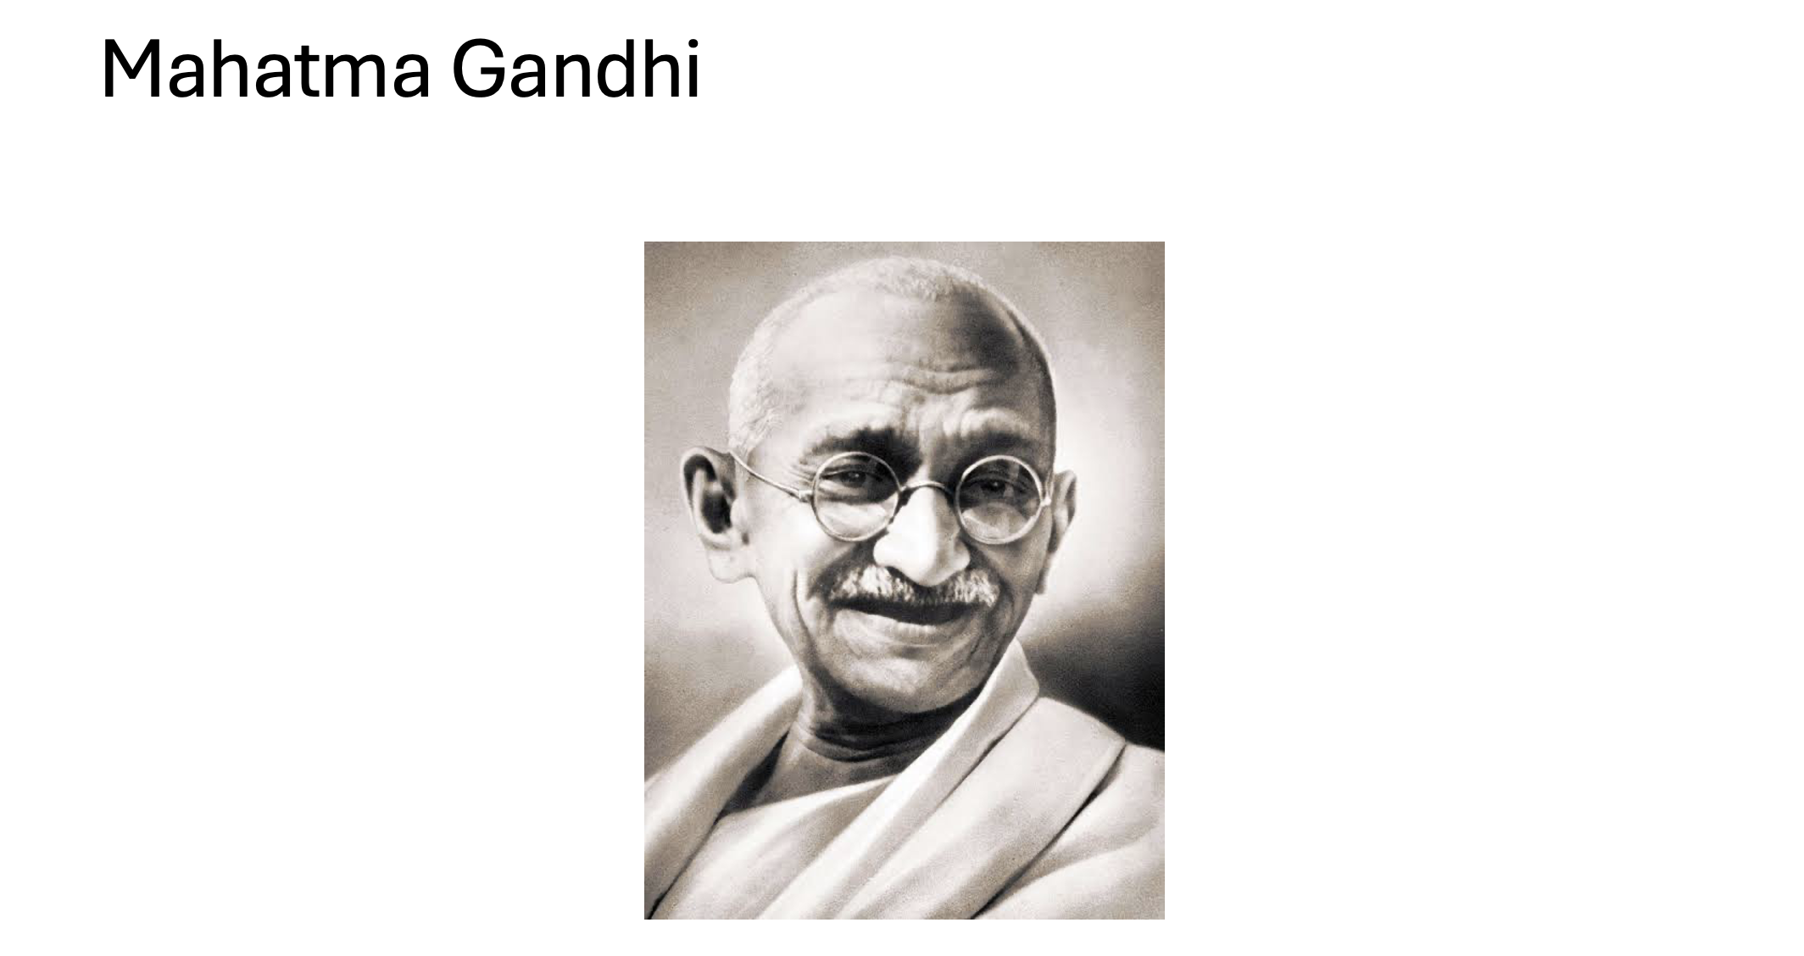

knitr::include_graphics("slide6.png")

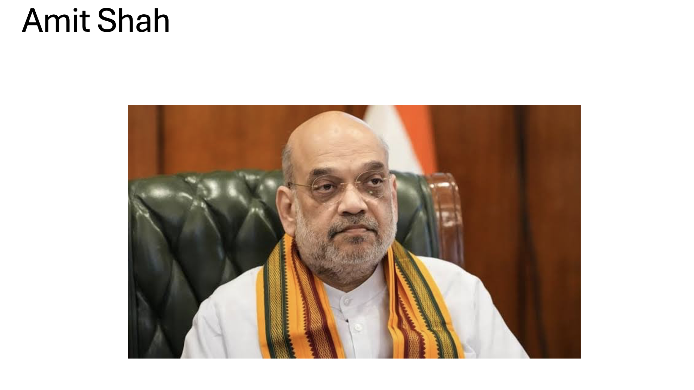

knitr::include_graphics("slide7.png")

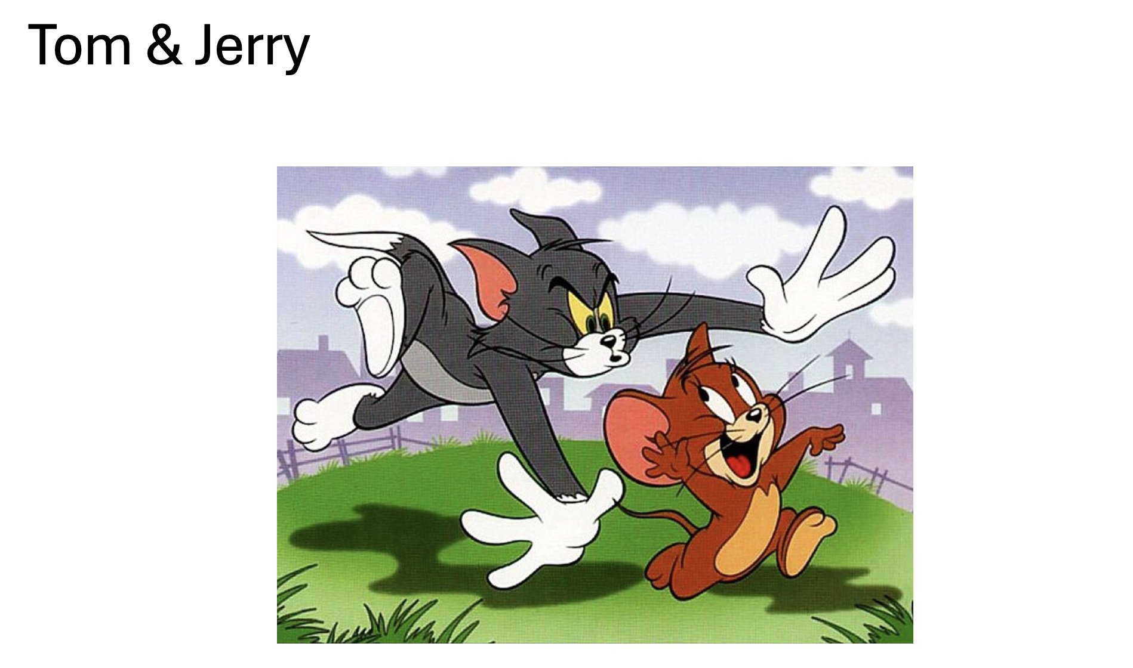

knitr::include_graphics("slide8.png")

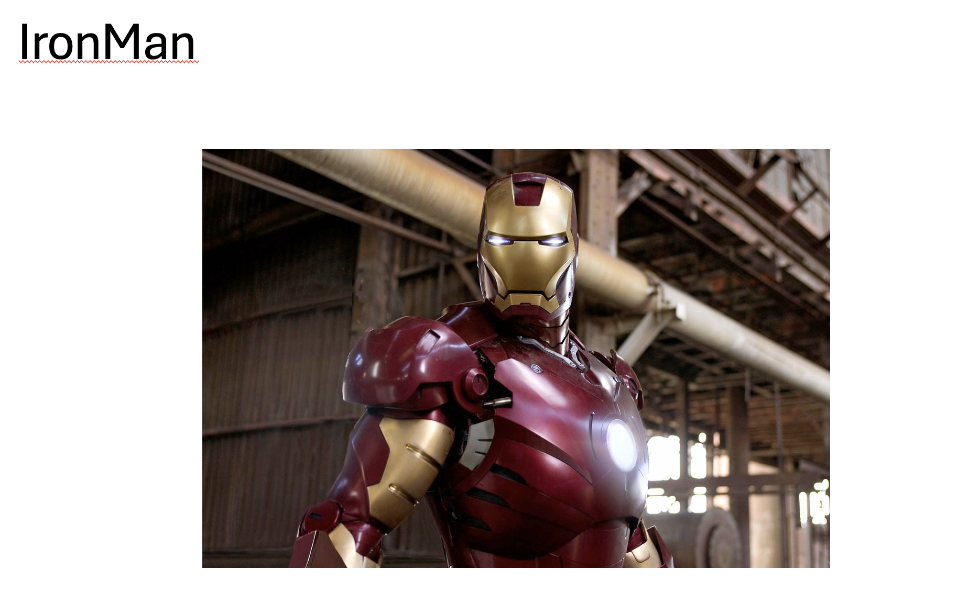

knitr::include_graphics("slide9.png")

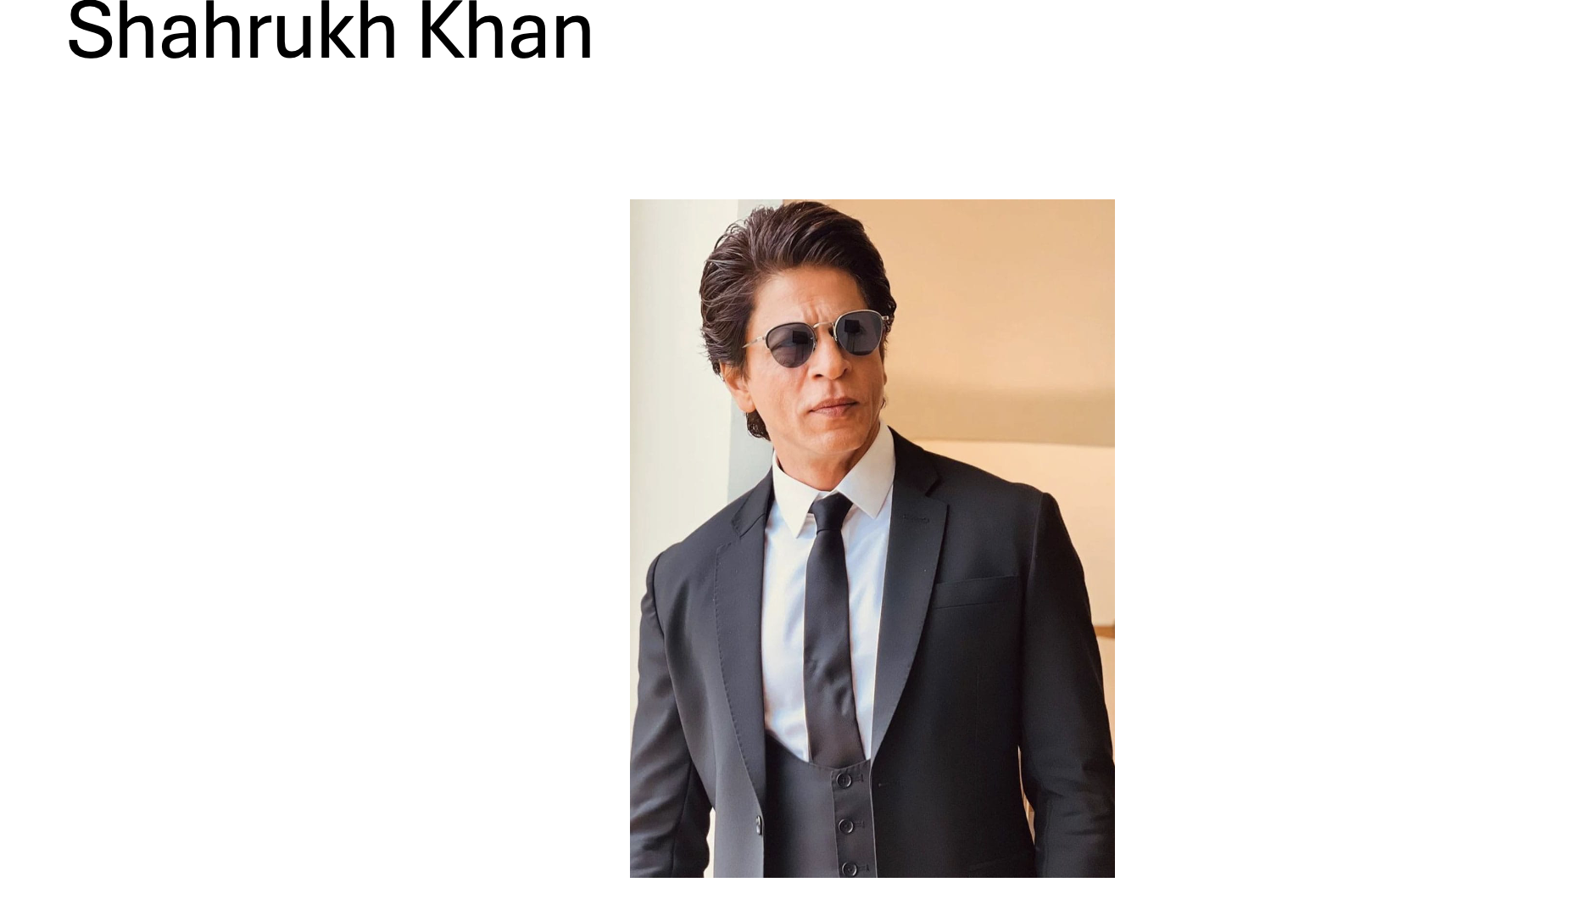

knitr::include_graphics("slide10.png")

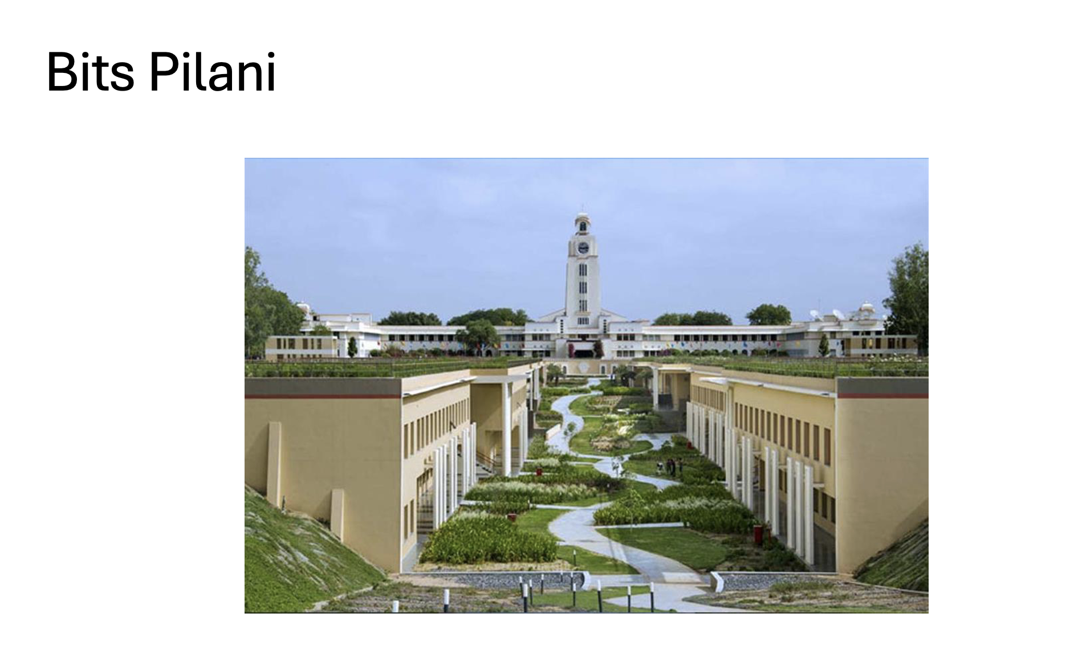

## Phase 3: Testing

After the exposure period:

1. Students were asked to recall as many images as possible.  
2. The number of images recalled was scored on a scale of 1 to 10.  
3. The number of pauses (hesitations) during the recall process was also recorded.

## Phase 4: Data Collection and Analysis

A total of 300 data points were collected and analyzed using statistical methods, including Three-Way ANOVA, to identify significant effects and interactions.

### Libraries used

library(tidyverse)

── Attaching core tidyverse packages ──────────────────────── tidyverse 2.0.0 ──  
✔ dplyr 1.1.4 ✔ readr 2.1.5  
✔ forcats 1.0.0 ✔ stringr 1.5.1  
✔ ggplot2 3.5.1 ✔ tibble 3.2.1  
✔ lubridate 1.9.3 ✔ tidyr 1.3.1  
✔ purrr 1.0.2   
── Conflicts ────────────────────────────────────────── tidyverse_conflicts() ──  
✖ dplyr::filter() masks stats::filter()  
✖ dplyr::lag() masks stats::lag()  
ℹ Use the conflicted package (<http://conflicted.r-lib.org/>) to force all conflicts to become errors

library(readxl)  
library(dplyr)  
library(ggplot2)

### Reading the data

data=read_excel("FinalStats_Datasheet.xlsx")

### Displaying the glimpse of data

glimpse(data)

Rows: 308  
Columns: 7  
$ BITS_ID <chr> "2023B5PS1128", "2024B4PS0990", "2023AAPS0778", "2024 …  
$ Name <chr> "AADITYA THAKKAR", "AANCHAL GARG", "AANYA JAIN", "Aar…  
$ Light_Intensity <chr> "Dim", "Dim", "Dim", "Bright", "Dim", "Dim", "Bright",…  
$ Sound_Intensity <chr> "Silent", "Silent", "Loud", "Silent", "Loud", "Silent"…  
$ Gender <chr> "M", "F", "F", "M", "M", "F", "M", "M", "M", "M", "M",…  
$ Score <dbl> 7, 8, 7, 8, 8, 9, 7, 6, 4, 9, 9, 6, 8, 8, 7, 7, 6, 7, …  
$ No_of_Pause <dbl> 3, 3, 1, 3, 4, 1, 2, 2, 2, 1, 3, 1, 3, 1, 3, 2, 2, 4, …

### Summary of the data

summary(data)

BITS_ID Name Light_Intensity Sound_Intensity   
 Length:308 Length:308 Length:308 Length:308   
 Class :character Class :character Class :character Class :character   
 Mode :character Mode :character Mode :character Mode :character   
   
   
   
 Gender Score No_of_Pause   
 Length:308 Min. : 4.000 Min. :1.000   
 Class :character 1st Qu.: 6.000 1st Qu.:1.000   
 Mode :character Median : 7.000 Median :2.000   
 Mean : 6.792 Mean :1.925   
 3rd Qu.: 8.000 3rd Qu.:3.000   
 Max. :10.000 Max. :4.000

### Rename columns for easier access

colnames(data) <- c("BITS_ID", "Name", "Light_Intensity", "Sound_Intensity", "Gender", "Score", "No_of_Pause")

### Final Data

glimpse(data)

Rows: 308  
Columns: 7  
$ BITS_ID <chr> "2023B5PS1128", "2024B4PS0990", "2023AAPS0778", "2024 …  
$ Name <chr> "AADITYA THAKKAR", "AANCHAL GARG", "AANYA JAIN", "Aar…  
$ Light_Intensity <chr> "Dim", "Dim", "Dim", "Bright", "Dim", "Dim", "Bright",…  
$ Sound_Intensity <chr> "Silent", "Silent", "Loud", "Silent", "Loud", "Silent"…  
$ Gender <chr> "M", "F", "F", "M", "M", "F", "M", "M", "M", "M", "M",…  
$ Score <dbl> 7, 8, 7, 8, 8, 9, 7, 6, 4, 9, 9, 6, 8, 8, 7, 7, 6, 7, …  
$ No_of_Pause <dbl> 3, 3, 1, 3, 4, 1, 2, 2, 2, 1, 3, 1, 3, 1, 3, 2, 2, 4, …

### Getting count of data points for all possible combinations:

combination_counts <- data |>   
 group_by(Light_Intensity, Sound_Intensity, Gender) |>   
 summarise(Count = n(), .groups = 'drop')  
  
# View the result  
print(combination_counts)

# A tibble: 8 × 4  
 Light_Intensity Sound_Intensity Gender Count  
 <chr> <chr> <chr> <int>  
1 Bright Loud F 30  
2 Bright Loud M 40  
3 Bright Silent F 34  
4 Bright Silent M 36  
5 Dim Loud F 35  
6 Dim Loud M 45  
7 Dim Silent F 37  
8 Dim Silent M 51

### Convert independent variables to factors

data$Light_Intensity <- as.factor(data$Light_Intensity)  
data$Sound_Intensity <- as.factor(data$Sound_Intensity)  
data$Gender <- as.factor(data$Gender)

### Three-way ANOVA for Score

model_score <- aov(Score ~ Light_Intensity * Sound_Intensity * Gender, data = data)  
summary(model_score)

Df Sum Sq Mean Sq F value Pr(>F)   
Light_Intensity 1 7.5 7.49 6.304 0.01257 *   
Sound_Intensity 1 113.1 113.10 95.239 < 2e-16 ***  
Gender 1 9.9 9.88 8.324 0.00420 **   
Light_Intensity:Sound_Intensity 1 7.0 7.00 5.893 0.01579 *   
Light_Intensity:Gender 1 2.6 2.60 2.191 0.13989   
Sound_Intensity:Gender 1 0.3 0.26 0.216 0.64272   
Light_Intensity:Sound_Intensity:Gender 1 8.1 8.12 6.839 0.00937 **   
Residuals 300 356.3 1.19   
---  
Signif. codes: 0 '***' 0.001 '**' 0.01 '*' 0.05 '.' 0.1 ' ' 1

### Three-way ANOVA for No of Pause

model_pause <- aov(No_of_Pause ~ Light_Intensity * Sound_Intensity * Gender, data = data)  
summary(model_pause)

Df Sum Sq Mean Sq F value Pr(>F)  
Light_Intensity 1 0.08 0.0848 0.135 0.714  
Sound_Intensity 1 0.99 0.9928 1.575 0.210  
Gender 1 0.11 0.1122 0.178 0.673  
Light_Intensity:Sound_Intensity 1 0.31 0.3081 0.489 0.485  
Light_Intensity:Gender 1 0.81 0.8062 1.279 0.259  
Sound_Intensity:Gender 1 0.50 0.4986 0.791 0.374  
Light_Intensity:Sound_Intensity:Gender 1 1.41 1.4058 2.231 0.136  
Residuals 300 189.07 0.6302

## Interpretation of Results

### Three-Way ANOVA for Score (Recalling Capacity)

1. Significant Effects:  
• Light Intensity: F = 6.304 , p = 0.01257   
Light intensity significantly impacts recalling capacity. This indicates that the level of lighting can influence students’ recall performance.   
• Sound Intensity: F = 95.239 , p \< 2e\^{-16}   
Sound intensity has a highly significant effect on recalling capacity, confirming that high noise levels negatively impact recall ability.   
• Gender: F = 8.324 , p = 0.00420   
Gender significantly affects recalling capacity, implying gender-related cognitive differences under the given environmental conditions.

• Interaction Effects:  
• Light Intensity × Sound Intensity: F = 5.893 , p = 0.01579   
A significant interaction suggests that the combined effect of light and sound intensity on recalling capacity is more substantial than their individual effects.  
• Light Intensity × Sound Intensity × Gender: F = 6.839 , p = 0.00937   
A significant three-way interaction reveals that the combined influence of light intensity, sound intensity, and gender strongly impacts recall.

2. Non-Significant Effects:  
• Light Intensity × Gender and Sound Intensity × Gender interactions are not statistically significant ( p \> 0.05 ).

### Three-Way ANOVA for No. of Pauses

1. Non-Significant Effects:  
• All main effects (Light Intensity, Sound Intensity, Gender) and interactions have p > 0.05 , indicating no statistically significant relationship between these factors and the number of pauses students take during the test.  
2. Implications:  
• The number of pauses during the test is unaffected by the tested environmental factors or gender.

## Interaction Plot:

aggregated_data <- data %>%  
 group_by(Light_Intensity, Sound_Intensity) %>%  
 summarise(Average_Score = mean(Score, na.rm = TRUE), .groups = "drop")  
  
  
interaction_plot <- ggplot(aggregated_data, aes(x = Light_Intensity, y = Average_Score, color = Sound_Intensity, group = Sound_Intensity)) +  
 geom_line(size = 1.2) +  
 geom_point(size = 3) +  
 labs(  
 title = "Interaction Effects of Light and Sound Intensity on Score",  
 x = "Light Intensity",  
 y = "Average Score",  
 color = "Sound Intensity"  
 ) +  
 theme_minimal()

Warning: Using `size` aesthetic for lines was deprecated in ggplot2 3.4.0.  
ℹ Please use `linewidth` instead.

print(interaction_plot)

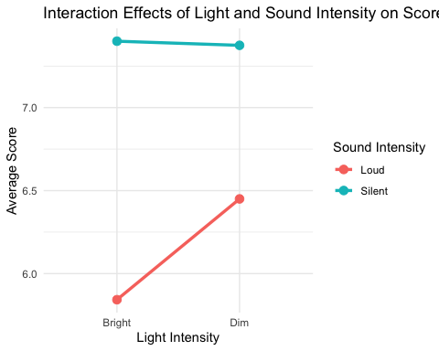

### Interpretation of the above plot:

Light Intensity:  
The Bright condition shows a noticeable difference in scores between the two Sound Intensity levels.  
The Dim condition shows a smaller difference in scores between the two Sound Intensity levels

Sound Intensity:  
Loud Sound Intensity has a lower average score for Bright Light but improves significantly under Dim Light.Silent Sound Intensity maintains relatively higher scores across both Light Intensities, with a slight decrease under Dim Light.

Interaction Effect:  
The non-parallel lines indicate an interaction between Light Intensity and Sound Intensity:  
Loud Sound Intensity interacts positively with Dim Light, improving scores.  
Silent Sound Intensity remains stable across Light Intensities, with minor variations.

General Insights:  
Dim Light seems to reduce the negative effects of Loud Sound, making it more conducive to higher scores.  
Silent conditions generally support better performance, regardless of Light Intensity.

Possible Implications:  
Environments with Dim Lighting can mitigate the disruptive effects of Loud Sound.  
Bright Light conditions seem to exacerbate the negative effects of Loud Sound.

## Boxplot: Score Distribution by Light and Sound Intensity

boxplot <- ggplot(data, aes(x = Light_Intensity, y = Score, fill = Sound_Intensity)) +  
 geom_boxplot() +  
 labs(  
 title = "Score Distribution by Light and Sound Intensity",  
 x = "Light Intensity",  
 y = "Score",  
 fill = "Sound Intensity"  
 ) +  
 theme_minimal()  
  
print(boxplot)

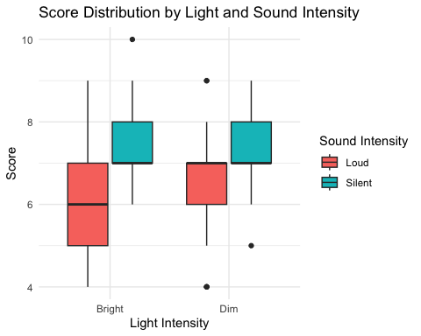

### Interpretation of the above plot:

Bright Light Intensity:  
  
Loud Sound:  
Scores have a lower median and a wider range, indicating higher variability in performance.  
Some outliers exist in the lower range, showing extreme cases of low scores.  
  
Silent Sound:  
Scores have a higher median and are tightly clustered, showing consistent performance.  
Few outliers exist in the upper range, indicating very high scores in some cases.  
Dim Light Intensity:

Loud Sound:  
Scores are slightly better distributed compared to Bright Light, with a moderate median and range.  
  
Silent Sound:  
Scores have a higher median than Loud Sound under Dim conditions.  
Distribution remains tight with less variability compared to Loud Sound.

Possible Conclusions:

Performance Impact:  
  
Silent Sound improves scores across both light intensities, with Dim Light being slightly more conducive to better scores.  
Loud Sound has a disruptive impact, especially under Bright Light.

Recommendations:  
  
For tasks requiring better scores, prefer Silent Sound conditions.  
Dim Light can help alleviate some of the negative effects of Loud Sound.

## Violin Plot: Score by Gender

violin_plot <- ggplot(data, aes(x = Gender, y = Score, fill = Gender)) +  
 geom_violin() +  
 labs(  
 title = "Score Distribution by Gender",  
 x = "Gender",  
 y = "Score"  
 ) +  
 theme_minimal()  
  
print(violin_plot)

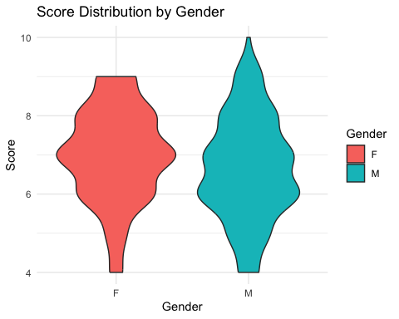

### Interpretation of the above plot:

Female (F):  
  
The distribution of scores is relatively narrow, indicating consistent performance among females.  
The median score appears to be higher compared to males.  
There are few extreme scores (outliers) at the lower and upper ends, but overall the distribution is stable.

Male (M):  
  
The distribution of scores is wider, showing more variability in performance among males.  
The range of scores spans from very low to very high, indicating diverse performance levels.  
The median score is slightly lower than that of females, but there are individuals with very high scores at the upper end.

Comparison of Genders:  
Females (F):  
More consistent scores with less variability.  
Higher median score, suggesting better overall performance on average.  
Males (M):  
Greater variability in scores, indicating a broader spectrum of performance.  
A wider range includes both low and high performers.

Insights:  
Females tend to perform more consistently, with scores clustering around a higher median.  
Males have a more diverse performance, with some excelling while others score much lower.

Possible Conclusions:  
Females might be benefiting from stable environmental or psychological factors that support consistent performance.  
The variability in males' scores could indicate different coping mechanisms or adaptability to conditions.

## Heatmap: Interaction Effects

heatmap_data <- data %>%  
 group_by(Light_Intensity, Sound_Intensity) %>%  
 summarise(Average_Score = mean(Score, na.rm = TRUE), .groups = "drop")  
  
heatmap_plot <- ggplot(heatmap_data, aes(x = Light_Intensity, y = Sound_Intensity, fill = Average_Score)) +  
 geom_tile(color = "white") +  
 scale_fill_gradient(low = "blue", high = "yellow") +  
 labs(  
 title = "Heatmap of Interaction Effects",  
 x = "Light Intensity",  
 y = "Sound Intensity",  
 fill = "Average Score"  
 ) +  
 theme_minimal()  
  
print(heatmap_plot)

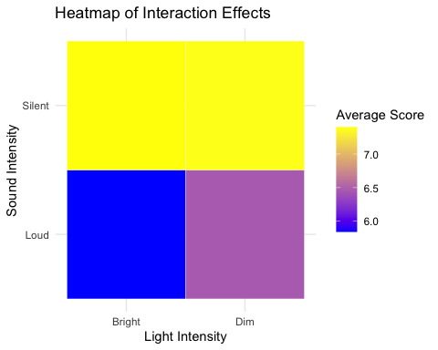

### Interpretation of the above plot:

Bright Light with Silent Sound:  
The highest average score is observed here (yellow), suggesting that this combination is the most favorable for performance.

Bright Light with Loud Sound:  
The lowest average score is observed here (blue), indicating this combination has a strong negative effect on performance.

`Dim Light with Silent Sound: Scores remain high (yellow), though slightly lower than Bright Light with Silent Sound, showing it is still a conducive condition for performance.

Dim Light with Loud Sound:  
Scores are moderate (purple), better than Bright Light with Loud Sound, suggesting Dim Light mitigates some of the disruptive effects of Loud Sound.

Interaction Insights:  
Sound Intensity Effects:  
Silent Sound consistently leads to higher scores, regardless of Light Intensity.  
Loud Sound significantly reduces scores, especially under Bright Light.

Light Intensity Effects:  
Bright Light enhances scores when combined with Silent Sound but worsens performance when paired with Loud Sound.Dim Light reduces the negative effects of Loud Sound but does not outperform Bright Light with Silent Sound.

Conclusions:

Best Condition:  
Bright Light and Silent Sound lead to the highest performance.  
  
Worst Condition:  
Bright Light and Loud Sound result in the lowest performance.

General Insights:  
Silent Sound is universally beneficial, but its advantage is maximized under Bright Light.  
Loud Sound is disruptive, particularly in Bright Light, but its impact is mitigated under Dim Light.

### Save all plots (optional)

ggsave("interaction_plot.png", plot = interaction_plot)

Saving 5 x 4 in image

ggsave("boxplot.png", plot = boxplot)

Saving 5 x 4 in image

ggsave("violin_plot.png", plot = violin_plot)

Saving 5 x 4 in image

ggsave("heatmap_plot.png", plot = heatmap_plot)

Saving 5 x 4 in image